WEST END BICYCLES
Business Process Flow
A Step-by-Step Build Guide
Odoo 19 Community Edition

How Odoo 19 Looks and Behaves
Odoo 19 changed several things from older tutorials and YouTube videos. If a screen does not match what you expected, it is almost always one of the points below. Spend five minutes here and the rest of the guide will feel obvious. The diagram below labels the five things you click most often.

Opening apps and moving around
- The main menu is the grid icon at the top-left. Click it to jump between Sales, Purchase, Inventory, Manufacturing, CRM, and so on.
- The horizontal bar near the top is the menu bar for the app you are in (for example Orders / Products / Reporting / Configuration).
- The grey trail at the very top-left (for example Sales / Quotations / S00001) is the breadcrumb. Click any part of it to step back without losing your place.
- Grey rounded buttons that sit above a record (for example Delivery, Invoices, Receipt) are smart buttons. They jump you to linked records and are how the different departments connect.

Creating and saving records (this is the biggest change)
In Odoo 16 and later there is no separate “Edit” button. When you open any record it is already editable — you just click a field and type. The save behaviour catches everyone out at first, so here is the rule once and for all:
- To start a brand-new record, click the purple New button at the top-left.
- To change an existing record, just click the field and type — no Edit button needed.
- When you have unsaved changes, a small cloud / save icon (and a “Discard” option) appears in the breadcrumb area. Click the cloud to save.
- Odoo also auto-saves when you navigate away, so leaving the record keeps your changes.
Note Wherever this guide says “Save”, it means click that cloud / save icon (or simply move to another record).

Product types (the other big change)
The old “Storable Product” type no longer exists. A physical item is now Product Type = Goods, and you tick a separate Track Inventory checkbox to make Odoo keep a stock count. In other words: the old “Storable Product” equals Goods plus Track Inventory enabled. Everything in this guide uses that wording.
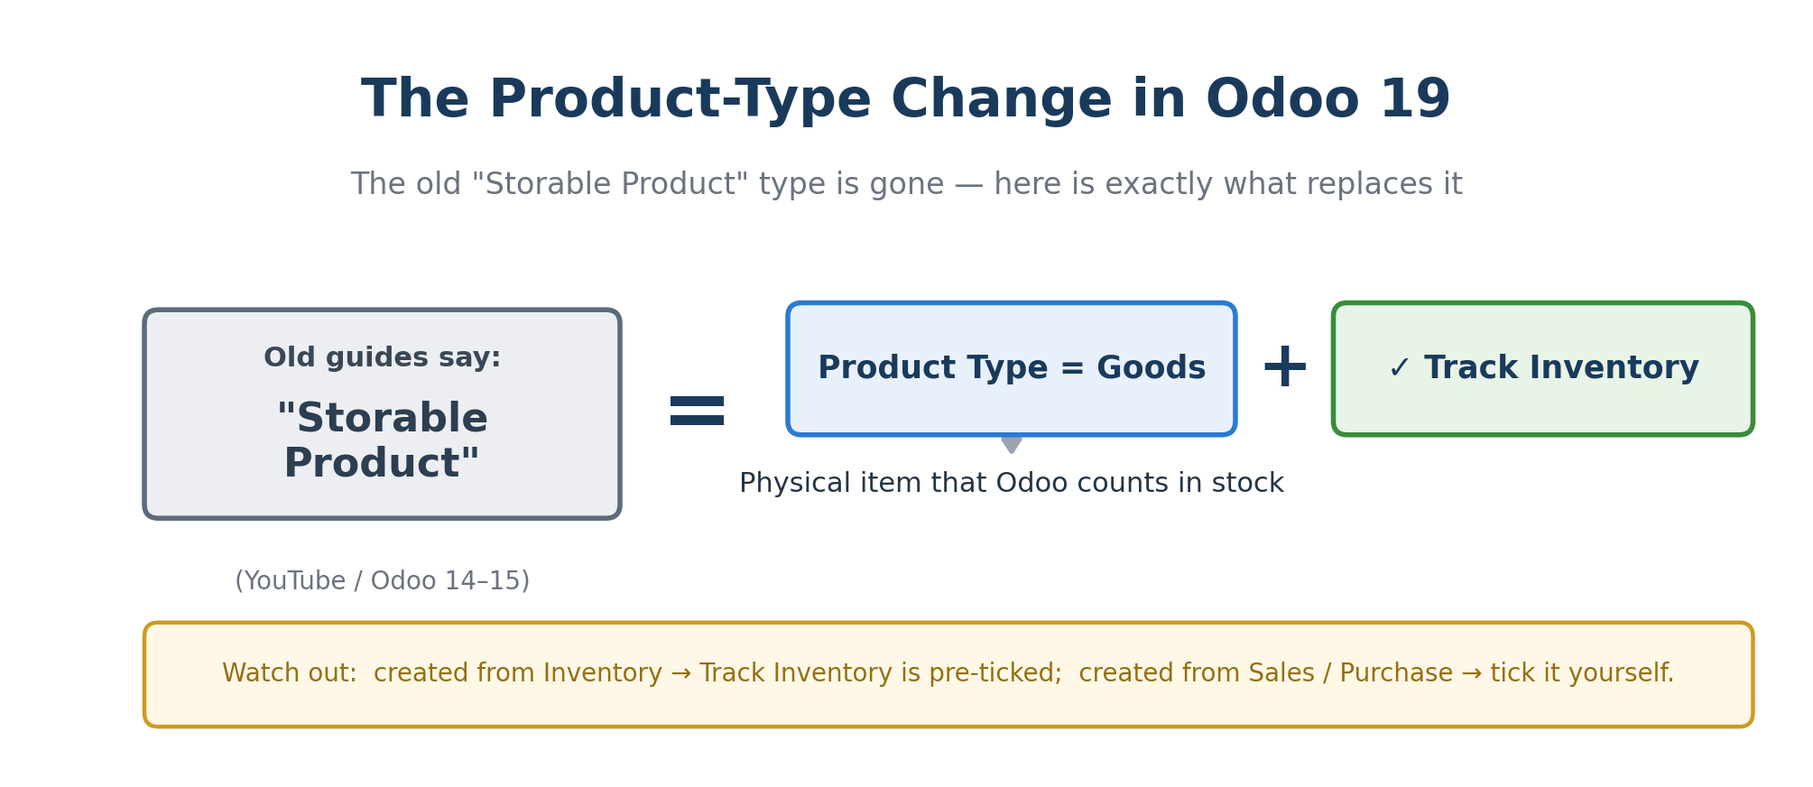
Figure 2. The old “Storable Product” maps to Product Type = Goods + Track Inventory.
Watch out When you create a product from inside the Inventory app, Track Inventory is ticked for you. When you create it from Sales or Purchase, it may be unticked by default — always confirm the checkbox so stock moves are recorded.

Community vs Enterprise
- In Community the finance app is called Invoicing, not the full Accounting module. Invoicing is enough for this assignment — it creates invoices and registers payments.
- A few Enterprise-only extras (Studio, advanced Accounting reports, the mobile Shop Floor tablet view) are not present, and you do not need them here.
- Everything this assignment requires — Contacts, CRM, Sales, Purchase, Inventory, Manufacturing, Employees, and Invoicing — is included in Community.

Developer mode (optional but handy)
If a field mentioned here is hidden, turn on developer mode: Settings → scroll to the bottom → Developer Tools → Activate the developer mode. You can turn it off the same way. You will not need it for the core flow, but it makes troubleshooting easier.

Key Business Concepts

Why use an ERP at all?
An ERP (Enterprise Resource Planning) system like Odoo keeps every department working from the same shared data. When Sales confirms an order, Inventory already knows what to ship and Finance already knows what to bill. West End Bicycles runs two connected cycles: a buying cycle that fills the warehouse, and a selling cycle that empties it. Both meet at Inventory and Manufacturing.
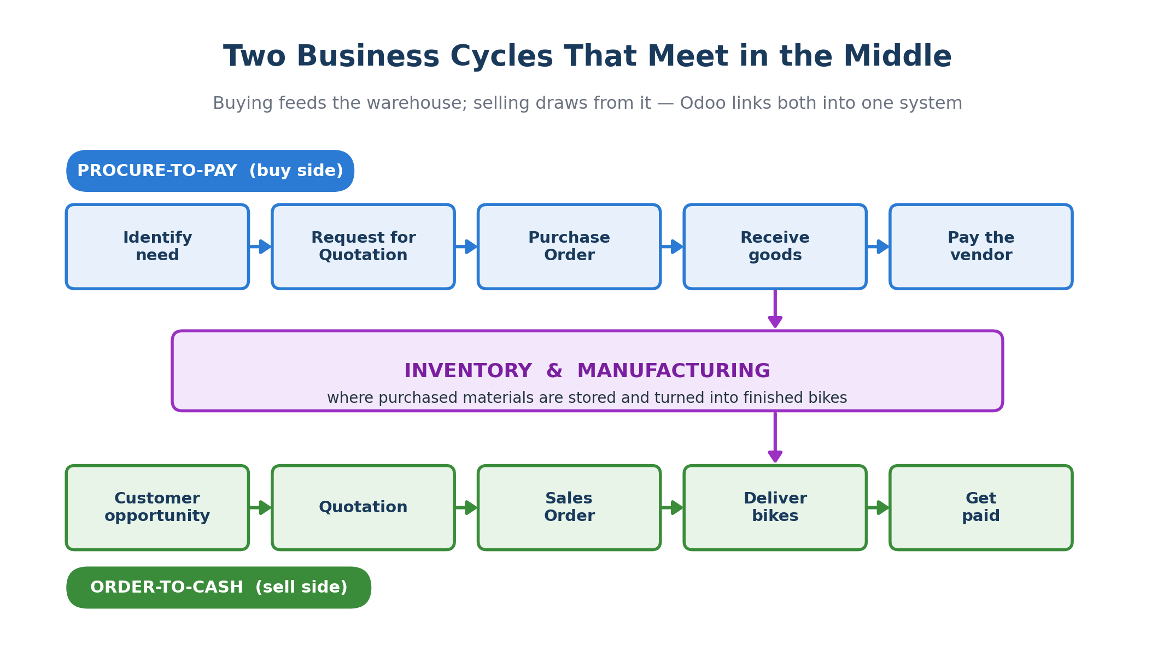
Figure 3. The procure-to-pay and order-to-cash cycles both meet at Inventory & Manufacturing.

Every document moves through the same three states
Almost every record in Odoo — a purchase order, a manufacturing order, a sales order, a delivery, an invoice — starts as an editable Draft, becomes a locked Confirmed document once you commit to it, and finally reaches Done when the real-world action is complete. Only the labels change between document types, as the map below shows.
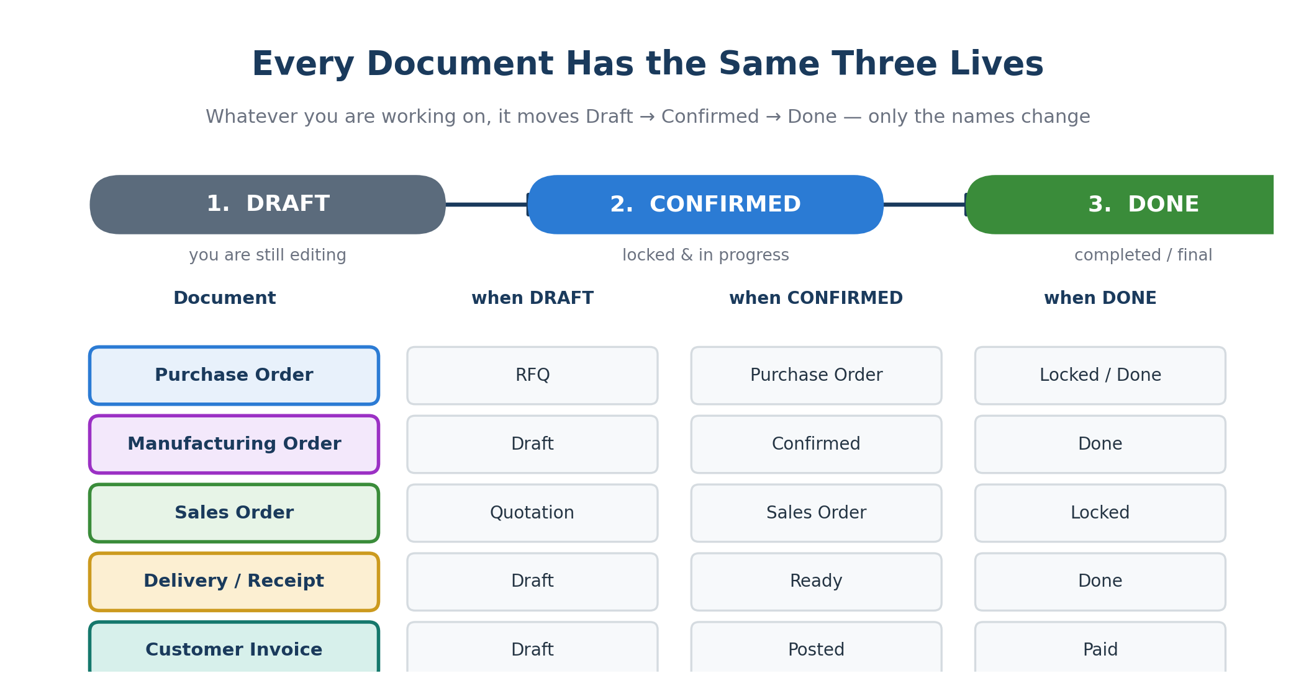
Figure 4. The Draft → Confirmed → Done lifecycle, and what each state is called per document.
Tip If a button you expect is missing, check the document's state first. For example, you can only Receive goods after a Purchase Order is Confirmed, and only Register Payment after an invoice is Posted.

How your records link together
Records are not islands — each one is created from, or feeds into, another. A vendor sits behind every purchase order; a Bill of Materials drives every manufacturing order; a sales order spawns both a delivery and an invoice. Understanding these links is what lets the smart buttons jump you instantly from one record to the next.
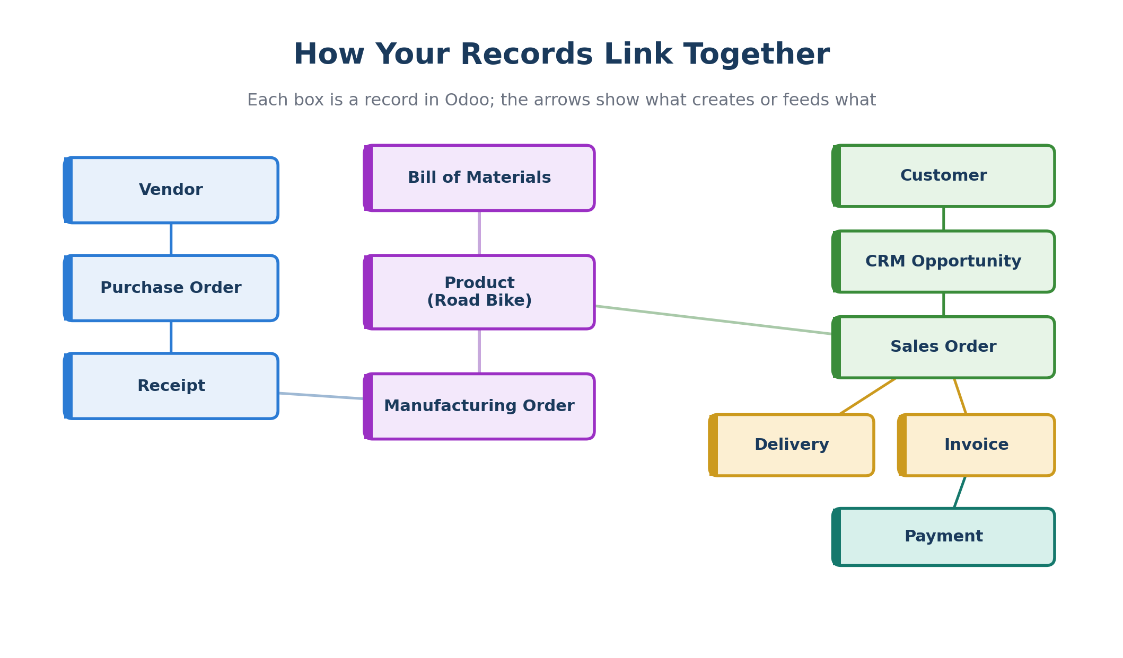
Figure 5. Each box is a record in Odoo; arrows show what creates or feeds what.

Make-to-stock: build first, sell from stock
West End Bicycles builds Road Bikes before a customer orders them, then sells from the finished-goods stock. This is called make-to-stock. It is why Parts C and D (buy and build) come before Parts E and F (sell and ship): you must have bikes on hand before you can deliver them. Odoo enforces this for you — it will not let you validate a delivery for stock you do not have.

The Demo Story
This is the single storyline your whole demo follows. Each numbered row maps to a screen you will produce in Odoo.
# | Business process | Odoo 19 screen / output you will show
1 | Buy raw materials | Purchase RFQ confirmed into a Purchase Order
2 | Receive raw materials | Receipt validated; on-hand stock increases
3 | Manufacture Road Bikes | Manufacturing Order marked Done; Road Bike stock increases
4 | Create a customer opportunity | CRM Pipeline opportunity card
5 | Create a quotation | Sales quotation for Road Bikes
6 | Confirm the sales order | Quotation becomes a Sales Order
7 | Deliver the bikes | Delivery Order validated; stock decreases
8 | Create the invoice | Customer invoice posted
9 | Register payment | Invoice status becomes Paid / In Payment
10 | Explain the information flow | Sales sends order & price data to Finance; Finance returns invoice & payment status

The Eight Apps You Will Use
Before building anything, it helps to see the whole toolkit at once. You install eight apps, and each one owns a clear part of the story. The diagram shows what each app does and how they connect into a single chain from purchasing to payment.
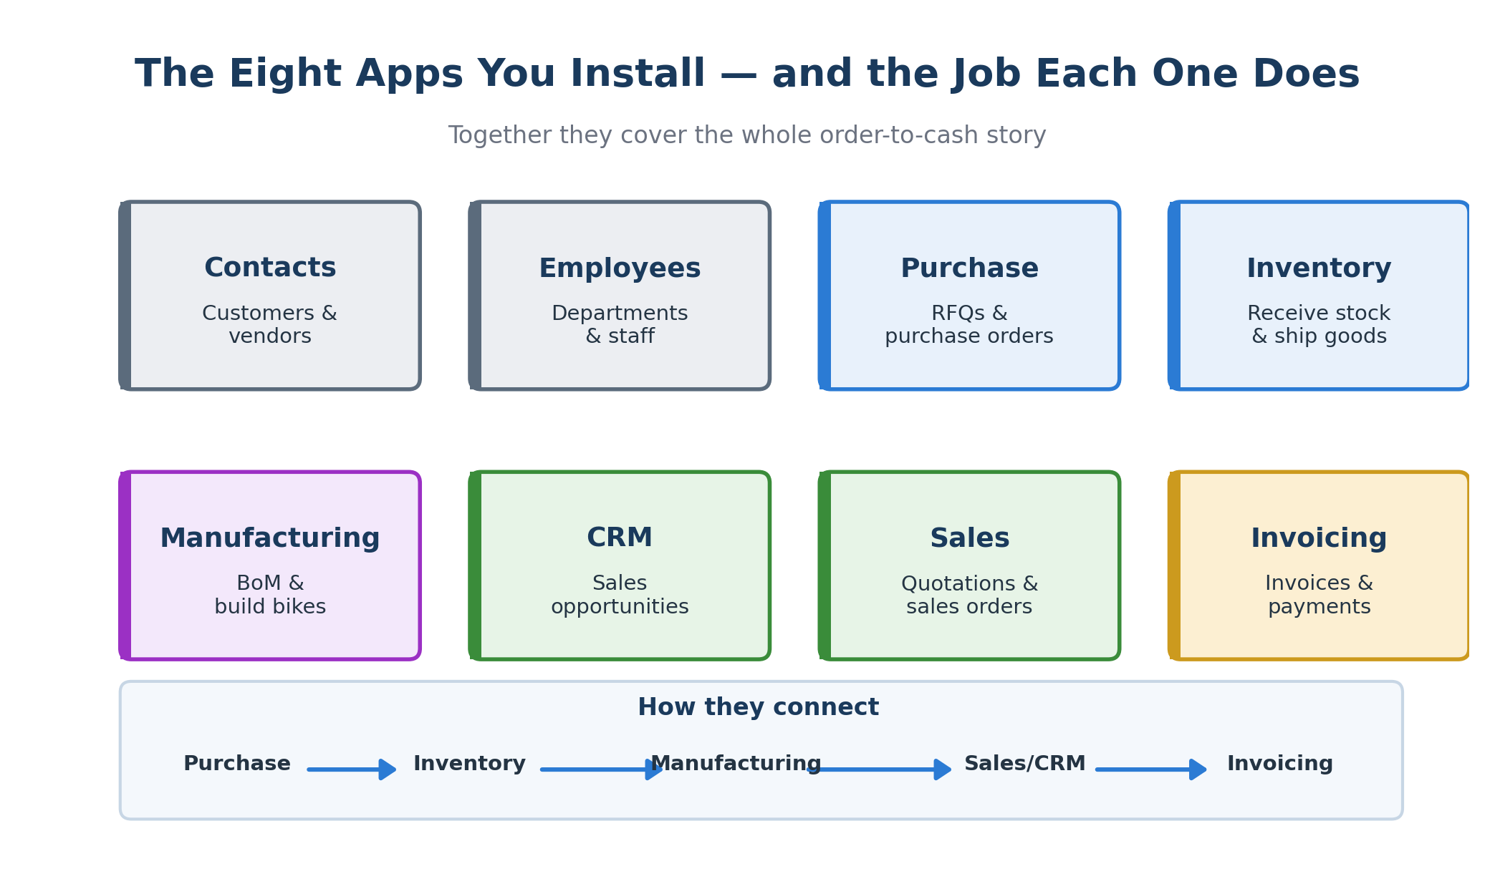
Figure 6. The eight Odoo apps and the job each one does.

Visual Overview
These two diagrams summarise the whole concept at a glance. The first shows how physical goods and money move through the business. The second traces the full step-by-step sequence you will build, grouped into four phases.

How stock and money move
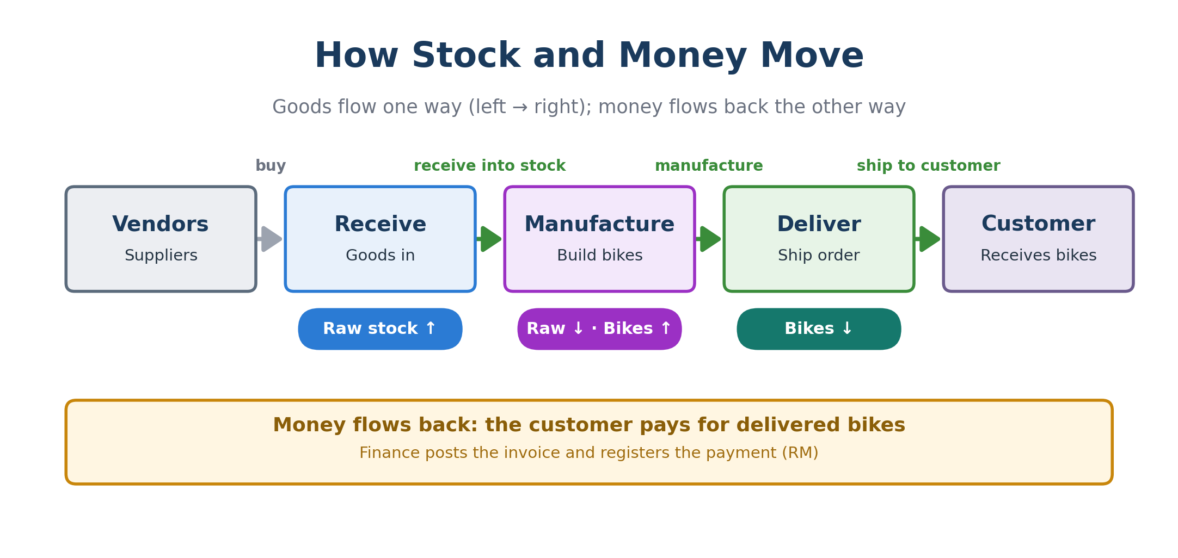
Figure 7. Goods flow left → right (vendors → receive → manufacture → deliver → customer); money flows back to Finance.

The end-to-end process
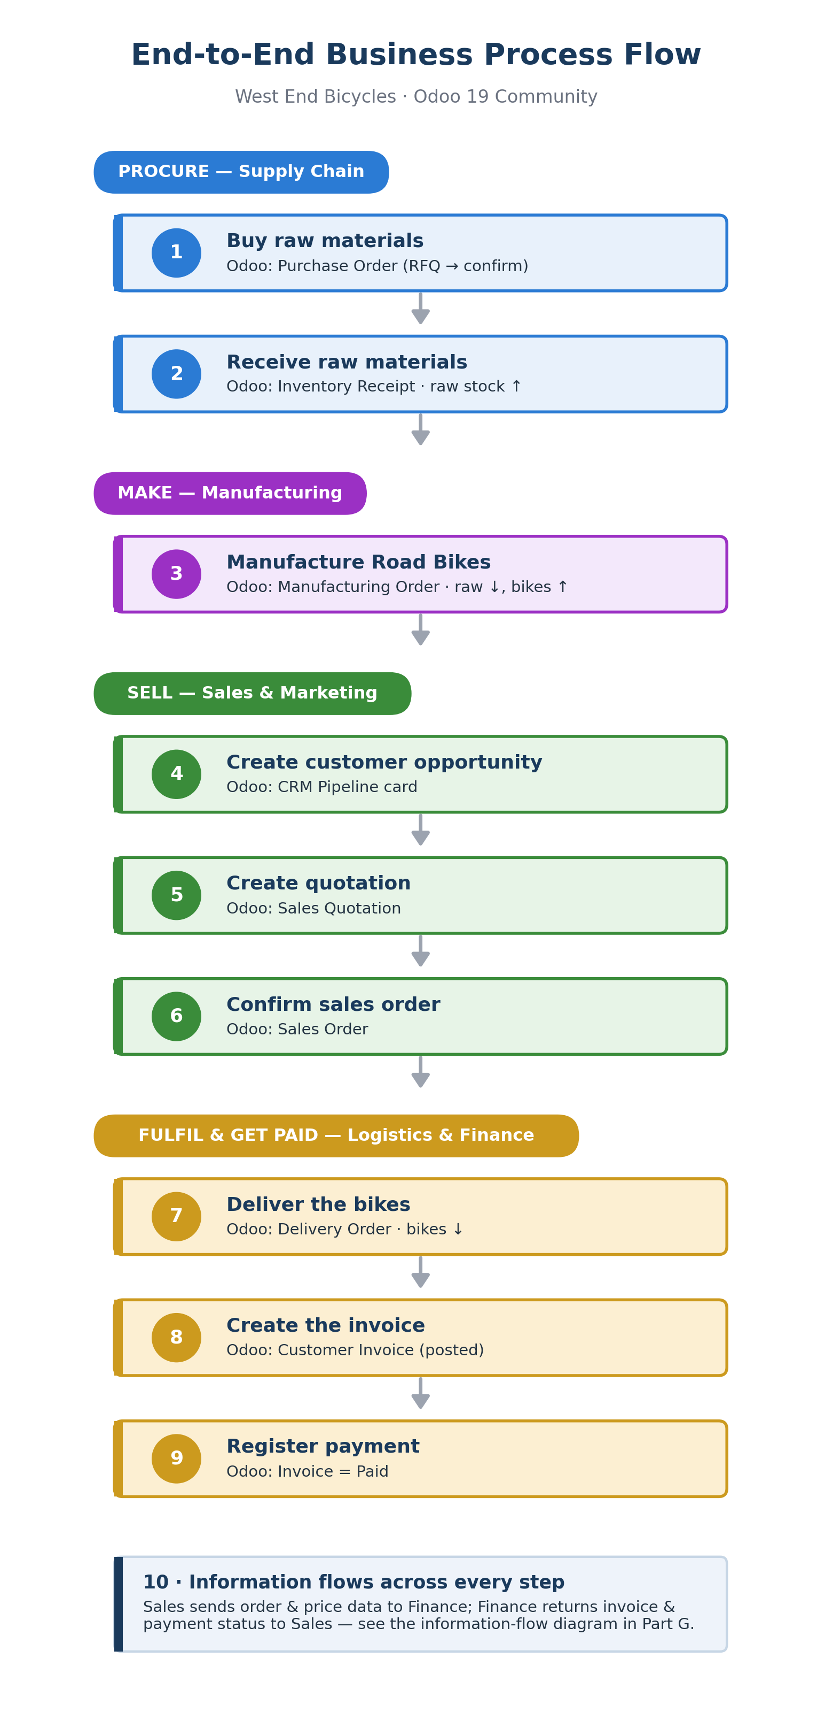
Figure 8. The nine build steps in four phases, with the Odoo 19 screen for each, plus the information-flow concept (Step 10).

Your build roadmap
The same work, viewed as a project plan. You will move through seven parts in order, A to G, completing 21 numbered steps. Each part builds on the one before, so resist the urge to skip ahead.
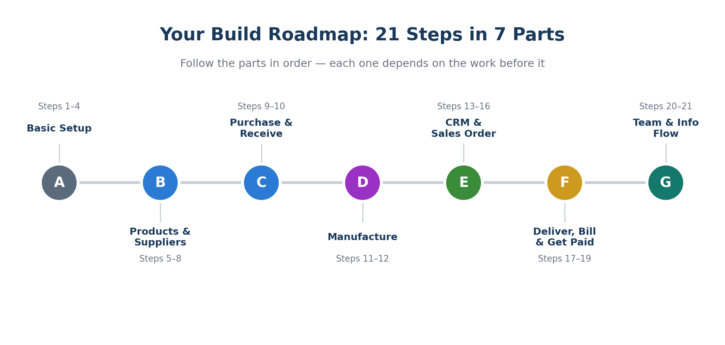
Figure 9. The 21 steps grouped into seven parts — follow them in order.

Part A — Basic Setup
In this part you create the database, install the apps, name the company, and set up the people behind the process. Nothing here moves stock yet — it builds the foundation everything else sits on.

Step 1. Create the database
If you are running Odoo 19 Community locally or on your own server, you start at the Database Manager screen.
Where to find it: Browser address bar → /web/database/manager
- Open Odoo in your browser. If you land on a login screen with no database yet, type /web/database/manager in the address bar to reach the Database Manager.
- Click Create Database.
- Master Password: set in your Odoo configuration file (often blank or “admin” on a fresh install). Enter it if asked.
- Database Name: type west_end_bicycles (lowercase, no spaces).
- Email: use your own email — this becomes the admin login.
- Password: create one you will remember; you log in with this email + password.
- Language: English. Country: Malaysia (sets currency to MYR / RM and a sensible chart of accounts).
- Demo data: leave unticked / choose “Do not load demo data” so your screenshots show only records you created.
- Click Create Database and wait. Odoo builds the database and logs you in to the home dashboard.
What you'll see After a short build, the Odoo home dashboard with the apps grid. Your database now exists.
Screenshot Capture the Database Manager creation form, or the first home dashboard after login, as proof your database exists.
Important On Odoo Online (odoo.com) there is no Database Manager — your database is created when you sign up. In that case skip to Step 2. This guide assumes a local Community install.

Step 2. Install the required apps
You install eight apps. Install them one at a time; the first one can take a minute and may pull in helper modules automatically — that is normal.
Where to find it: Main menu (grid) → Apps
- Open the Apps menu (grid icon → Apps).
- In the search box, clear any “Apps” filter so every module is visible (Community sometimes hides categories).
- Search each app name from the table below, one at a time.
- Click Activate / Install on each.
App | Why you need it
Contacts | Stores customers, vendors, and all contact information.
CRM | Creates and tracks sales opportunities in the pipeline.
Employees | Creates departments and employee records.
Inventory | Receives raw materials and ships finished bikes; keeps stock counts.
Invoicing | Creates customer invoices and registers payments (Community finance app).
Manufacturing | Builds the Bill of Materials and Manufacturing Orders.
Purchase | Creates RFQs, Purchase Orders, and vendor receipts.
Sales | Creates quotations and confirms sales orders.
Note Installing Sales, Purchase, and Manufacturing pulls in Inventory automatically because they all move stock. If Inventory is already installed afterwards, you can skip installing it separately.
What you'll see Each installed app shows an “Installed” badge and now appears in the main menu grid.
Screenshot Capture the Apps screen showing the installed (activated) modules.

Step 3. Set up the company profile
Naming the company now means it appears automatically on every quotation, invoice, and delivery slip you generate later.
Where to find it: Settings → Users & Companies → Companies
- Open Settings from the main menu.
- Go to Users & Companies → Companies.
- Click the existing company record to open it (it is editable immediately — no Edit button).
- Fill in the fields below by clicking each field and typing.
- Click the cloud / save icon to save (or navigate away to auto-save).
Field | Value to enter
Company Name | West End Bicycles
City | Ipoh
State | Perak
Country | Malaysia
Phone | Optional
Website | Optional
Screenshot Capture the completed company profile form.

Step 4. Create departments and employees
These records are the organisation behind the process — and this step now makes them do real work. By the end of it, the people you create here will own actual documents: a salesperson on the quotation, a buyer on the purchase order, and a person responsible for the manufacturing order. That is what turns a list of names into an ERP, rather than a directory that sits unused.
Where to find it: Employees → Departments (then) Employees → Employees

First, create the four departments
- Open the Employees app.
- Go to Departments.
- Click New, type the department name, and save.
- Leave the Manager field empty for now — you will set each department’s head once the employees exist, a few bullets down.
- Repeat for all four departments in the table.

Then, add a few sample employees
- Go to Employees → Employees.
- Click New and enter the employee name — use the role names from the table (for example, Sales Manager).
- In the Department field, choose the matching department.
- Under the employee’s name, type the same text in the Job Position box (for example, Sales Manager) so the record carries a real title instead of being an empty shell.
- Open the Work Information tab and enter a Work Email (for example, sales.manager@westend.example). You’ll need this shortly to give the operational roles a login.
- In the Manager field, set who this person reports to. Add each department’s lead first — Sales Manager, Finance Officer, Purchasing Officer, HR Officer — leaving their Manager blank; for everyone else, pick their department’s lead. That gives you a simple two-level reporting line and a real org chart.
- Save, then repeat for every employee in the table.
Department | Sample employees to add
Sales and Marketing | Sales Manager, Sales Executive, Marketing Officer
Accounting and Finance | Accountant, Finance Officer
Supply Chain | Purchasing Officer, Inventory Officer, Production Planner
Human Resources | HR Officer, Training Officer

Now set each department’s head
- Go back to Employees → Departments and open each department in turn.
- In the Manager field, pick its head — Sales and Marketing → Sales Manager; Accounting and Finance → Finance Officer; Supply Chain → Purchasing Officer; Human Resources → HR Officer — then save. Odoo now knows who leads each team, and the org chart fills in.

Turn the four operational roles into users
Why this matters In Odoo, an Employee (an HR record) and a User (a login) are two different things. The Salesperson, Buyer and Responsible fields on documents point to users, not to HR employees — so an HR-only record can never be chosen there. Giving four of your people a login, then linking each via the Related User field, is what lets them own a quotation, a purchase order or a manufacturing order.
- Go to Settings → Users & Companies → Users and click New.
- Create one user for each operational role, using its work email as the login: Sales Manager, Purchasing Officer, Production Planner, and Accountant. (The other employees can stay HR-only — they show the org structure but never need to sign in.)
- Give each user the access it needs so it appears in the right dropdown later: Sales: User for the Sales Manager, Purchase: User for the Purchasing Officer, Manufacturing / Inventory: User for the Production Planner, and Accounting (Billing) for the Accountant. Save.
- Link each user back to its employee: open the employee, go to the HR Settings tab, and set Related User to the matching login. The HR record and the user are now the same person.
- You do not have to log in as them. Stay signed in as the admin — later you simply pick these names in the Salesperson, Buyer and Responsible fields.

Who gets stamped on what
This is exactly where each of the four people reappears later. Keep it handy as you build the rest of the workflow — every row is a place these records stop being decoration and start carrying responsibility.
Person | Odoo field they fill | Where it happens
Sales Manager | Salesperson | CRM opportunity (Step 14); quotation and sales order (Step 16); Team Leader of the sales team (Step 20)
Purchasing Officer | Buyer | Requests for quotation and purchase orders (Step 9)
Production Planner | Responsible | Manufacturing order (Step 12)
Accountant | Registers payment | Customer payment (Step 19); add as a follower on the invoice (Step 18)
Screenshot Capture three things: the Departments view (each department now shows its manager and headcount), the org chart for one department, and the Users list with your four operational logins.

Part B — Products, Raw Materials, and Suppliers
Now you build the catalogue: the bikes you sell, the components you buy, the vendors who supply them, and the link that connects each vendor to its material. The sourcing map shows where this part is heading.
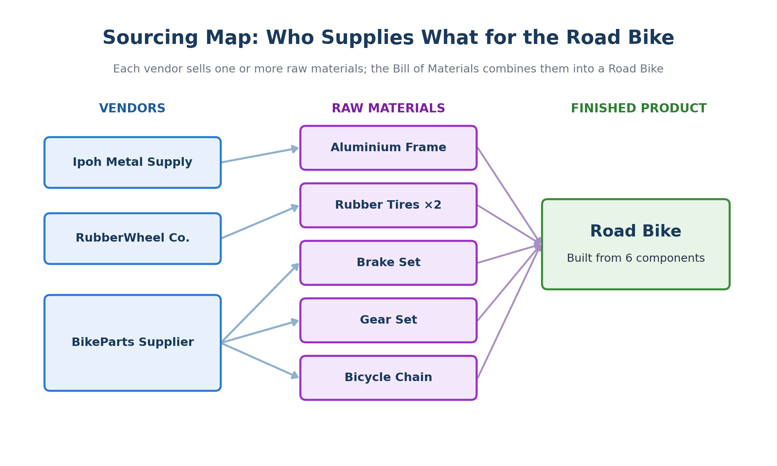
Figure 10. Which vendor supplies which raw material, and how the components combine into a Road Bike.

Step 5. Create the finished products
These are the items you sell. The Road Bike is the one you will actually manufacture later, so give it special attention.
Where to find it: Sales → Products → Products (Inventory works too)
- Open Sales → Products → Products.
- Click New and enter the Product Name (for example, Road Bike).
- Tick Can be Sold.
- Set Product Type = Goods, then tick Track Inventory so Odoo keeps a stock count (this replaces the old “Storable Product” type).
- Leave Unit of Measure as Units.
- On the General Information tab, set the Sales Price (for example RM 1,000 for the Road Bike).
- Save, then repeat for every finished product in the table.
Finished product | Type | Track Inv. | Can Sell | Sales Price
Road Bike | Goods | Yes | Yes | RM 1,000
Mountain Bike | Goods | Yes | Yes | RM 1,200
City Bike | Goods | Yes | Yes | RM 800
Helmet | Goods | Yes | Yes | RM 100
Cycling Shoes | Goods | Yes | Yes | RM 150
Cycling Shirt | Goods | Yes | Yes | RM 80
Watch out If you do not see a “Track Inventory” checkbox, the Inventory app is not installed — install it (Step 2). That checkbox is what makes the product behave like the old “Storable” type.
What you'll see The saved Road Bike form shows Product Type = Goods and Track Inventory ticked. An “On Hand” smart button appears (reading 0 for now).
Screenshot Capture the Road Bike product form clearly showing Product Type = Goods and Track Inventory ticked.

Step 6. Create the raw material products
These are the components you buy from suppliers and consume when manufacturing the Road Bike.
Where to find it: Purchase → Products → Products
- Open Purchase → Products → Products and click New.
- Enter the raw material name (for example, Aluminium Frame).
- Tick Can be Purchased. You may untick Can be Sold — these are not sold to customers in this demo.
- Set Product Type = Goods and tick Track Inventory.
- On the Purchase tab (or General Information), set the Cost (for example RM 200 for the Aluminium Frame).
- Save, then repeat for every raw material.
Raw material | Type | Track Inv. | Can Buy | Cost
Aluminium Frame | Goods | Yes | Yes | RM 200
Carbon Fiber Frame | Goods | Yes | Yes | RM 350
Rubber Tires | Goods | Yes | Yes | RM 40
Brake Set | Goods | Yes | Yes | RM 70
Gear Set | Goods | Yes | Yes | RM 90
Bicycle Chain | Goods | Yes | Yes | RM 30
Note Cost vs Sales Price: Cost is what you pay the vendor (used on purchase orders); Sales Price is what the customer pays (used on quotations).

Step 7. Create the suppliers / vendors
Vendors are simply contacts marked as companies. You will link them to the materials they supply in the next step.
Where to find it: Purchase → Orders → Vendors
- Open Purchase → Orders → Vendors (the Contacts list filtered to vendors).
- Click New.
- Choose Company (not Individual) at the top of the contact form.
- Enter the vendor name. Optionally add email / phone / address for nicer screenshots.
- Save, then repeat for all vendors.
Vendor | What they supply (for your reference)
Ipoh Metal Supply | Aluminium Frame
CarbonTech Components | Carbon Fiber Frame
RubberWheel Co. | Rubber Tires
BikeParts Supplier | Brake Set, Gear Set, Bicycle Chain
Important The “What they supply” column is not a field on the vendor record — it is just for your reference. You link a vendor to its products on the product itself, in Step 8.

Step 8. Link each vendor to its raw material
This connection lets Odoo suggest the right vendor and price when you raise a purchase order.
Where to find it: Purchase → Products → Products → open a raw material → Purchase tab
- Open Purchase → Products → Products and click a raw material (for example, Aluminium Frame).
- Open the Purchase tab on the product form.
- Under Vendor (the vendor pricelist section), click Add a line.
- Choose the vendor (for example, Ipoh Metal Supply).
- Set Quantity (minimum) to 1 and Price (for example RM 200).
- If a Delivery Lead Time column shows, set it (for example 3 days).
- Save, then repeat for every raw material.
Raw material | Vendor to add (Purchase tab) | Min Qty | Vendor Price
Aluminium Frame | Ipoh Metal Supply | 1 | RM 200
Carbon Fiber Frame | CarbonTech Components | 1 | RM 350
Rubber Tires | RubberWheel Co. | 1 | RM 40
Brake Set | BikeParts Supplier | 1 | RM 70
Gear Set | BikeParts Supplier | 1 | RM 90
Bicycle Chain | BikeParts Supplier | 1 | RM 30
Watch out If you cannot see the Purchase tab, make sure the Purchase app is installed and that Can be Purchased is ticked on the product.
Screenshot Capture a raw material product showing a vendor line under the Purchase tab — this proves the vendor is linked to the material.

Part C — Purchasing and Receiving Raw Materials
Now you actually buy the components and bring them into stock. Every purchase follows the same short sequence, shown below: a request becomes an order, the order produces a receipt, and validating the receipt raises your stock.
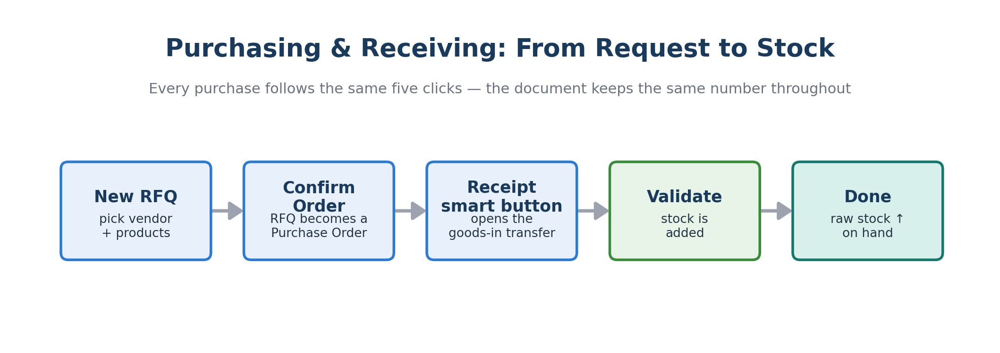
Figure 11. The purchasing sequence — the same document keeps its number from RFQ all the way to a Done receipt.

Step 9. Raise RFQs and order the raw materials
Create one RFQ (Request for Quotation) per vendor — each purchase order belongs to a single vendor, so grouping by vendor is cleanest. Order enough material to build at least 5 Road Bikes, with a little spare.
Where to find it: Purchase → Orders → Requests for Quotation
- Open Purchase → Orders → Requests for Quotation and click New.
- In the Vendor field, choose the vendor.
- Open the Other Information tab and set Buyer to the Purchasing Officer. This stamps every purchase order with the person from Supply Chain who owns it.
- Under the product lines, click Add a product, pick the raw material, and set the Quantity.
- Add more product lines if the vendor supplies several materials.
- Save the RFQ.
- Click Confirm Order — the document number stays the same but the status moves to Purchase Order and a Receipt smart button appears.
- Repeat for the remaining vendors.
RFQ | Vendor | Products and quantities
RFQ 1 | Ipoh Metal Supply | Aluminium Frame: 20
RFQ 2 | RubberWheel Co. | Rubber Tires: 40
RFQ 3 | BikeParts Supplier | Brake Set: 20; Gear Set: 20; Bicycle Chain: 20
Note The Carbon Fiber Frame is optional here because the Road Bike recipe in Step 11 uses the Aluminium Frame. Order it only if you want a fuller purchasing screenshot.
What you'll see Status changes from “RFQ” to “Purchase Order”, and a Receipt smart button (showing a count) appears at the top.
Screenshot Capture a confirmed Purchase Order.

Step 10. Receive the purchased materials into stock
The default warehouse uses one-step receiving, so validating the receipt immediately adds the goods to on-hand stock.
Where to find it: Open the Purchase Order → Receipt smart button (or Inventory → Operations → Receipts)
- Open a confirmed Purchase Order and click the Receipt smart button at the top.
- Check the Done / Demand quantities (for this demo they can match the ordered quantity).
- Click Validate.
- If a Backorder pop-up appears (because you received less than ordered), click Validate again or No Backorder as appropriate. A full receipt needs no pop-up.
- The receipt status becomes Done. Repeat for every Purchase Order.
Tip To prove stock went up, open any received raw material and check the On Hand smart button — the quantity should now match what you received. This is the Supply Chain process in action: purchase → receive → inventory updated.
What you'll see The receipt status reads “Done”, and the material's On Hand count rises by the received quantity.
Screenshot Capture a validated receipt (status Done).

Part D — Manufacturing the Road Bike
With components in stock, you can build bikes. First you define the recipe (the Bill of Materials), then you run a Manufacturing Order that consumes raw materials and produces finished Road Bikes.
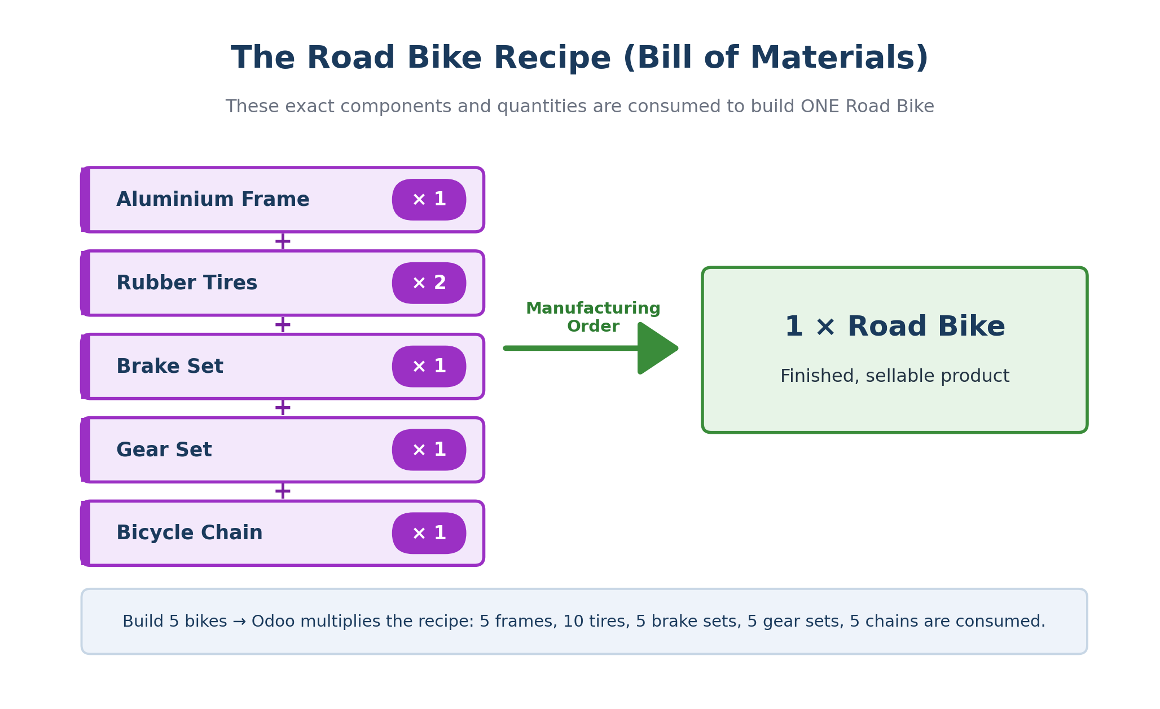
Figure 12. The Road Bike Bill of Materials — the exact components consumed to build one bike.

Step 11. Create the Bill of Materials (BoM)
A BoM is the recipe: it tells Odoo which components and quantities are consumed to build one Road Bike.
Where to find it: Manufacturing → Products → Bills of Materials
- Open Manufacturing → Products → Bills of Materials and click New.
- In Product, choose Road Bike.
- Set Quantity to 1 (the BoM describes how to build one bike).
- On the Components tab, click Add a line and add each component with its quantity from the table.
- Save.
Component | Quantity for 1 Road Bike
Aluminium Frame | 1
Rubber Tires | 2
Brake Set | 1
Gear Set | 1
Bicycle Chain | 1
Note Leave the Operations tab empty. With no operations there are no Work Orders, which keeps the Manufacturing Order in Step 12 simple (one click to produce).
Screenshot Capture the Road Bike BoM showing all five components.

Step 12. Manufacture the Road Bikes
Running the Manufacturing Order is where stock visibly transforms: raw materials go down, finished bikes go up. The diagram shows the before-and-after for a batch of five.
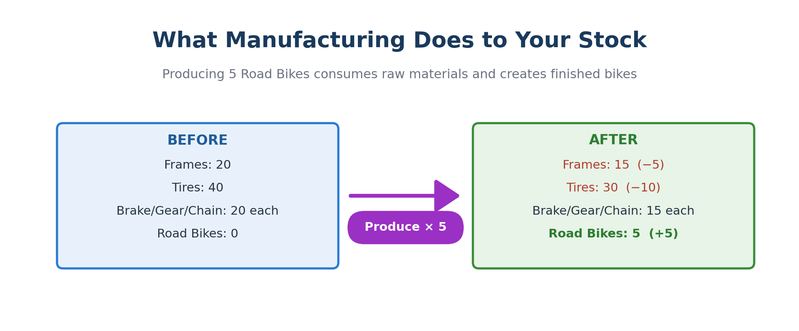
Figure 13. Producing 5 Road Bikes consumes raw materials and creates 5 finished bikes.
Where to find it: Manufacturing → Operations → Manufacturing Orders
- Open Manufacturing → Operations → Manufacturing Orders and click New.
- In Product, choose Road Bike. The Bill of Materials fills in automatically; if not, pick the Road Bike BoM in the Bill of Material field.
- Set Quantity to 5.
- In the Responsible field, choose the Production Planner. Manufacturing now has a named owner for this build, not just a blank field.
- Click Confirm. Odoo reserves the components and the status moves to Confirmed.
- Click Check Availability if component availability is not already green.
- Click Produce All, then Mark as Done (on a simple MO you may see Mark as Done directly).
- If a pop-up asks about quantities or consumption, confirm / apply the full amount.
- The Manufacturing Order status becomes Done.
Note Older guides mention a single “Produce” button. In Odoo 19 a simple MO uses Produce All and Mark as Done. Because your BoM has no operations, expect a quick Confirm → Check Availability → Mark as Done.
Watch out If Odoo says components are not available, go back to Part C and confirm every receipt was Validated (status Done). Manufacturing can only consume materials that are actually on hand.
Tip Result to point out in class: raw material stock goes down and finished Road Bike stock goes up. Open the Road Bike product → On Hand should now read 5.
Screenshot Capture the Manufacturing Order with status Done.

Part E — Customer, CRM Opportunity, Quotation, and Sales Order
Now the selling side begins. You create the customer, capture the deal as a CRM opportunity, move it through the pipeline, and turn it into a confirmed sales order. The pipeline diagram shows the stages the opportunity passes through.
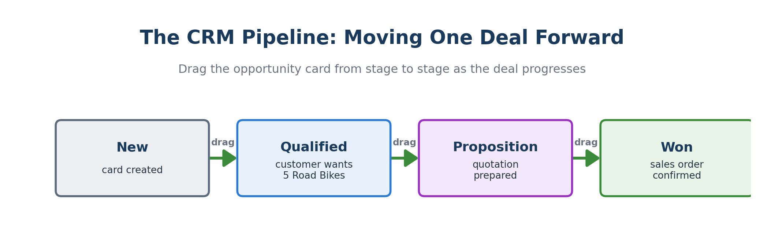
Figure 14. The CRM pipeline — drag the opportunity card forward as the deal progresses.

Step 13. Create the customer
The customer is a contact marked as a company, just like a vendor.
Where to find it: Sales → Orders → Customers (or the Contacts app)
- Open Sales → Orders → Customers and click New.
- Choose Company.
- Enter the customer details from the table below.
- Save.
Field | Value
Customer Name | Seri Iskandar Cycling Club
Type | Company
City | Seri Iskandar
State | Perak
Country | Malaysia
Email | SICC@example.com
What you'll see A saved customer record for Seri Iskandar Cycling Club, ready to attach to an opportunity and a quotation.

Step 14. Create a CRM opportunity
An opportunity is a card representing one potential deal. The pipeline starts empty — that is normal; you create the first card yourself.
Where to find it: CRM → (Pipeline appears on the dashboard)
- Open CRM. The Pipeline appears on the main dashboard.
- Click New (top-left).
- Opportunity (the title): Road Bike Order – Seri Iskandar Cycling Club.
- Customer: Seri Iskandar Cycling Club.
- Expected Revenue: RM 5,000 (5 bikes × RM 1,000).
- Salesperson: choose the Sales Manager — the Sales and Marketing user you set up in Step 4, so the opportunity is owned by a real person rather than the admin.
- Save. A card now appears under the New stage of the pipeline.
- Open the card to confirm the customer and expected revenue are correct.
Note Each card in the pipeline is one opportunity. An empty pipeline simply means no opportunity has been created yet — it is not an error.
What you'll see A card titled “Road Bike Order – Seri Iskandar Cycling Club” sitting in the New column, showing RM 5,000 expected revenue.
Screenshot Capture the pipeline showing your opportunity card, and/or the opened opportunity.

Step 15. Move the opportunity through the pipeline stages
Dragging the card between stages is how you tell the story of the deal progressing — from a fresh lead to a won sale.
Where to find it: CRM → Pipeline (drag cards between columns)
- Drag the card from New to Qualified.
- Open it and add an internal note, for example: “Customer requested 5 Road Bikes.”
- Drag it to Proposition when you are ready to prepare the quotation.
- After the sales order is confirmed (Step 16), mark the opportunity Won using the Won button at the top.
Note This shows the Marketing / Sales process: capturing a lead, qualifying it, following up, and forecasting revenue through the pipeline stages.

Step 16. Create the quotation from the opportunity
From the opportunity you spin up a quotation in one click — the customer carries over automatically. Confirming it turns the quotation into a Sales Order.
Where to find it: Open the CRM opportunity → New Quotation button
- Open the CRM opportunity card.
- Click the New Quotation button at the top-left. (If a Quotations smart button is shown instead, click it and create a new quotation.)
- Confirm the Customer is Seri Iskandar Cycling Club (it carries over from the opportunity).
- Check the Salesperson field shows the Sales Manager (it carries over from the opportunity; set it if blank). The confirmed sales order keeps this, so Sales owns the record from first contact to order.
- On the Order Lines tab, click Add a product and choose Road Bike.
- Set Quantity to 5 and check the unit price (RM 1,000).
- Save the quotation. Optionally click Send by Email to demonstrate the customer-communication step.
- Click Confirm — the quotation status changes to Sales Order.
Watch out The New Quotation button only appears when the Sales app is installed and a Customer is set on the opportunity. If it is missing: save the opportunity, make sure a customer is selected, and confirm both CRM and Sales are installed.
Important Backup route: if you still cannot create it from CRM, go to Sales → Orders → Quotations → New, pick Seri Iskandar Cycling Club, and optionally link the opportunity in the Other Info tab. The result is the same Sales Order.
What you'll see The order's status badge changes from “Quotation” to “Sales Order”, and Delivery / Invoice smart buttons appear at the top.
Screenshot Capture the confirmed Sales Order (status “Sales Order”).

Part F — Delivery, Invoice, and Payment
This part closes the loop: you ship the bikes, bill the customer, and record the money received. Notice that each document is created from the one before it via a smart button — the price you set in Sales flows all the way to the invoice without being retyped.
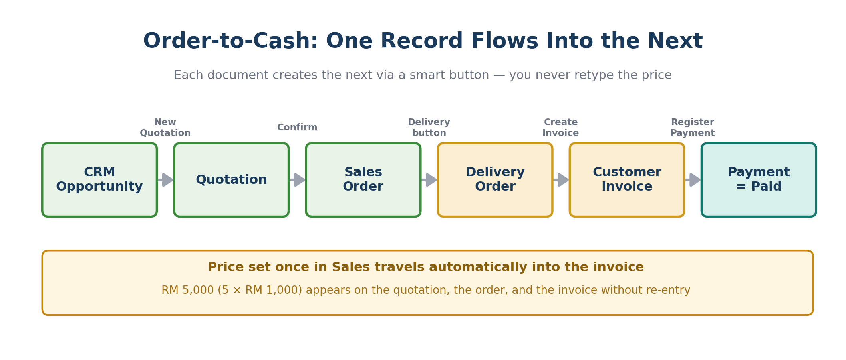
Figure 15. Order-to-cash — each record creates the next, and the price travels with it.

Step 17. Deliver the Road Bikes
Validating the delivery ships the bikes out of your warehouse, so finished-bike stock drops by the quantity sent.
Where to find it: Open the Sales Order → Delivery smart button
- Open the confirmed Sales Order and click the Delivery smart button at the top.
- Click Check Availability if the 5 bikes are not already reserved.
- Confirm 5 Road Bikes are reserved / available.
- Click Validate.
- If an Immediate Transfer / Backorder pop-up appears, choose Apply / Validate for the full quantity.
- The delivery status becomes Done.
Tip Result: Road Bike on-hand stock drops by 5 because the bikes left your warehouse for the customer.
What you'll see Delivery status reads “Done”; back on the Road Bike product, On Hand falls from 5 to 0.
Screenshot Capture the validated Delivery Order (status Done).

Step 18. Create the customer invoice
The invoice is generated straight from the Sales Order, so the product, quantity, and price are already filled in for you.
Where to find it: Sales Order → Create Invoice
- Go back to the Sales Order (use the breadcrumb, or the smart button at the top of the delivery).
- Click Create Invoice.
- Choose Regular Invoice and click Create Draft / Create and View Invoice.
- Review the invoice line: Road Bike, quantity 5, unit price, and total.
- Click Confirm to post the invoice. The status moves from Draft to Posted.
Note This is the Accounting / Finance process: the sales-order information flows automatically into a financial document. Notice you did not retype the price — it came from Sales.
What you'll see A posted invoice for RM 5,000 with the Road Bike line already populated; status reads “Posted”.
Screenshot Capture the posted invoice.

Step 19. Register the customer payment
Recording the payment tells Finance the money has arrived and lets Sales see that the customer has paid.
Where to find it: Open the posted invoice → Register Payment
- Open the posted invoice and click Register Payment.
- Journal: choose Bank or Cash.
- Payment Method: Manual is fine for the demo.
- Amount: leave it as the full invoice total.
- Payment Date: today.
- Click Create Payment.
- The invoice status updates to Paid (or In Payment, depending on configuration).
Note Result: Finance records the money received, and Sales can now see the customer has paid. The loop between departments is closed.
What you'll see A green PAID (or In Payment) ribbon across the invoice.
Screenshot Capture the invoice marked Paid / In Payment (the green PAID ribbon is ideal).

Part G — Cross-Functional Team and Information Flow
The final part makes the assignment's big idea explicit: fulfilling a customer order is a team effort spanning Sales, Marketing, and Finance — with information flowing continuously between them.

Step 20. Create a cross-functional sales team
A sales team groups the people involved in winning and fulfilling orders.
Where to find it: Sales → Configuration → Sales Teams
- Open Sales → Configuration → Sales Teams and click New.
- Sales Team: Customer Order Team.
- Team Leader: Sales Manager.
- Under Members, you can only add people who have a login. Add the Sales Manager here. The Sales Executive and Marketing Officer are HR-only employees (no login), so they can’t be members — add them as Followers instead, as below.
- Likewise, add the Finance Officer as a Follower on the customer, sales order, or invoice (the bell / follower icon at the top of those records).
- Save.
Note This supports the assignment idea that fulfilling a customer order spans Sales / Marketing and Finance, not a single department.

Step 21. Explain the information flow
Use the table to narrate what information moves where, then point to the diagram below it, which shows the same exchange visually — information moving between the customer, Sales/Marketing, and Finance.
Information exchanged | Where it appears in Odoo | What it means
Customer interest / order request | CRM Opportunity | Marketing / Sales captures customer demand.
Product, quantity, and price | Quotation & Sales Order lines | Sales passes order details to Finance and Operations.
Delivery status | Delivery Order | Inventory / Operations confirms goods were shipped.
Invoice amount | Customer Invoice | Finance creates the official financial record.
Payment status | Invoice status: Paid | Finance tells Sales the payment was received.
Sales & invoice reports | Sales / Invoicing reporting menus | Management reviews revenue and performance.
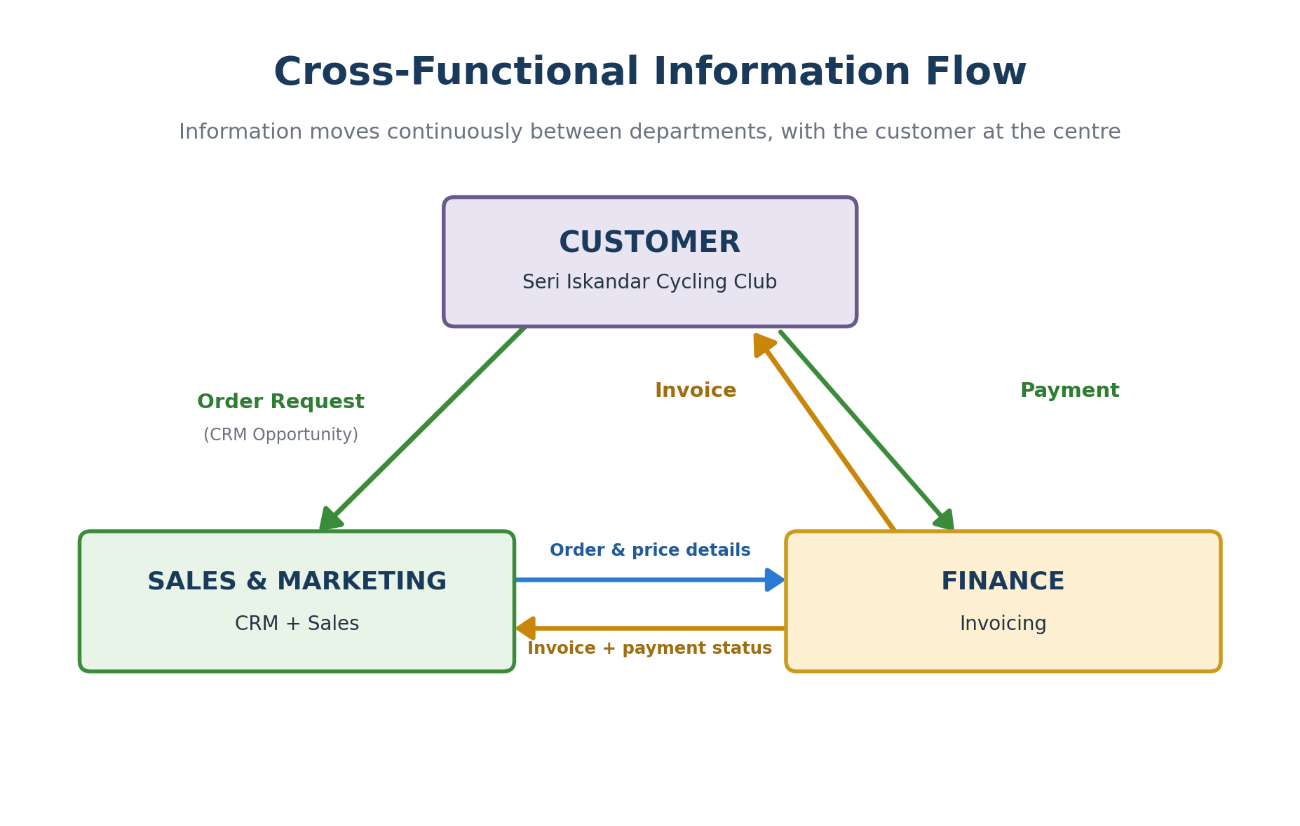
Figure 16. Cross-functional information flow between the customer, Sales/Marketing, and Finance.

Who Does What: Roles and Responsibilities
The assignment's central idea is that fulfilling a customer order is a team sport. No single department does everything — each one leads some steps and supports others. The matrix below maps the ten core processes to the four departments you created in Step 4, so you can narrate exactly who is responsible at each stage.
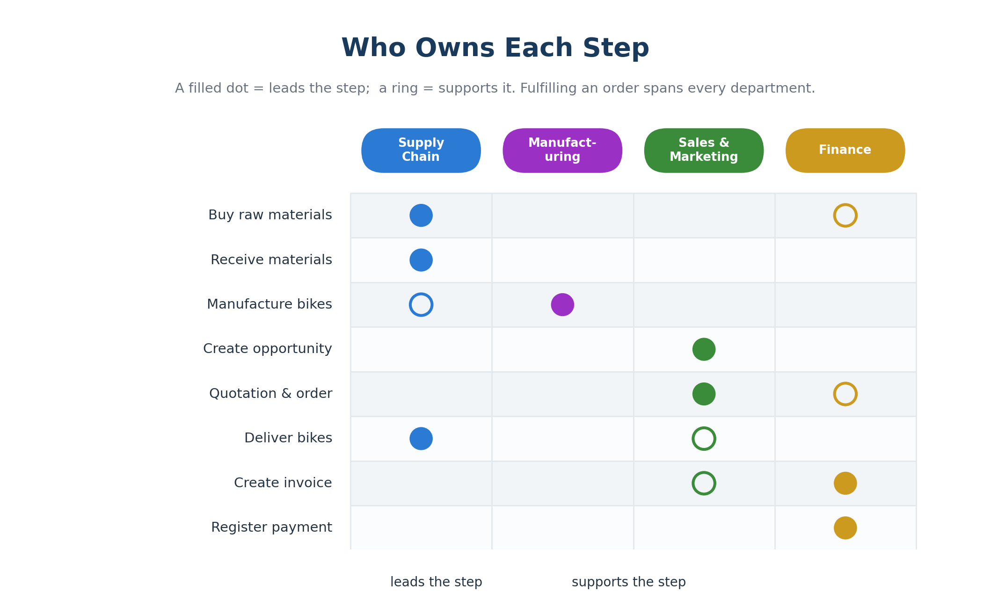
Figure 17. Which department leads (filled dot) and which supports (ring) at each step.
Read it across a row to see who touches a given process, or down a column to see everything one department owns. A few patterns are worth pointing out in your demo:
- Supply Chain owns the upstream half — buying, receiving, and shipping physical goods.
- Manufacturing is a specialist: it leads exactly one step (building the bikes) but depends on Supply Chain having materials on hand.
- Sales & Marketing owns the customer relationship — the opportunity, the quotation, and the order.
- Finance owns the money — invoicing and payment — and supports purchasing and order confirmation.
- Notice the hand-offs: the moment one department finishes its step, the next one's smart button lights up. That is the integration in action.

Reading the Results: Reporting and Dashboards
Once the process has run end to end, the data you created becomes management information. Community Edition includes solid reporting in every app — enough to prove the business outcomes for your demo. This is the final row of the information-flow table: management reviewing revenue and performance.

Where to find the key reports
Question to answer | Where to look in Odoo | View to use
How much have we sold? | Sales → Reporting | Graph or Pivot of confirmed orders
What has been invoiced and paid? | Invoicing → Reporting | Invoice analysis; aged receivables
What stock do we hold now? | Inventory → Reporting → Stock | On-hand quantities by product
How did materials move? | Inventory → Reporting → Moves History | Receipts in, deliveries out
How is the sales pipeline? | CRM → Reporting | Opportunities by stage / expected revenue
What did we manufacture? | Manufacturing → Reporting | Manufacturing orders by status

Switching between views
Most Odoo lists can be shown several ways using the small view-switch icons at the top-right of the screen. Knowing these turns raw lists into presentation-ready charts:
- List view — the default table of records; good for detail.
- Kanban view — cards in columns; the CRM pipeline uses this.
- Graph view — bar, line, or pie charts; ideal for a revenue slide.
- Pivot view — a spreadsheet-style cross-tab you can group and drill into.
Tip For a strong closing slide, open Sales → Reporting, switch to Graph view, and group by product. It instantly shows the RM 5,000 Road Bike sale you created — a clean visual proof that the whole process worked.
Screenshot Capture one report in Graph or Pivot view (for example Sales totals) to demonstrate the reporting / analysis stage.

Putting It All Together: The Stock Journey
If you remember one picture from this build, make it this one. It traces the two stock levels that matter — raw materials and finished Road Bikes — across the whole process, so you can see at a glance what each step does to your inventory.
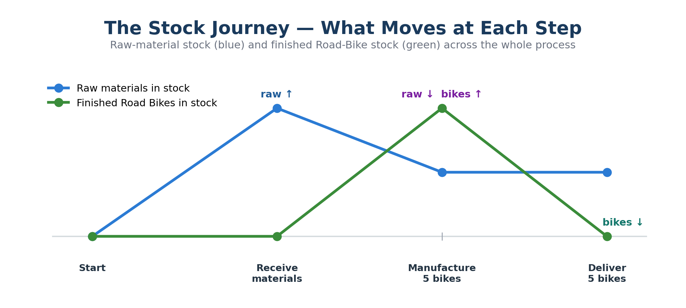
Figure 18. Raw-material stock (blue) and finished Road-Bike stock (green) across the whole process.
- Receive materials — raw-material stock jumps up as vendor receipts are validated.
- Manufacture 5 bikes — raw materials are consumed (down) while finished bikes appear (up).
- Deliver 5 bikes — finished-bike stock drops back to zero as the bikes ship to the customer.

Demo Day: Your Presentation Script
Use this as a teleprompter while you present. Each row gives you the screen to show and a one-line talking point that connects the click to the business meaning. Keep it to a steady, confident narration — the screens do the proving, your words supply the story.
Show this screen | Say something like…
Installed apps + company profile | “West End Bicycles runs eight integrated Odoo apps under one company.”
Confirmed Purchase Order | “Supply Chain orders frames, tires, and parts from our vendors.”
Validated receipt | “Goods arrive and stock rises automatically — no manual count.”
Road Bike Bill of Materials | “This recipe defines exactly what each bike consumes.”
Manufacturing Order – Done | “We build five bikes; raw materials fall and finished bikes appear.”
CRM opportunity card | “Sales captures a real deal: the cycling club wants five Road Bikes.”
Confirmed Sales Order | “One click turns the quote into a binding order — price set once.”
Validated Delivery Order | “We ship the bikes; stock drops to zero.”
Posted invoice | “Finance bills the customer — notice the price flowed across, not retyped.”
Invoice marked Paid | “Payment recorded; the order-to-cash loop is closed.”
Sales report (Graph view) | “And management sees the result instantly: RM 5,000 in revenue.”
Tip Rehearse the click path once before class. The most common slip is presenting out of order — the roadmap (Parts A–G) is also the order you should demo in.

Build Progress Checklist
Done? | Step | What “done” looks like
☐ | 1. Create the database | Logged in to the home dashboard.
☐ | 2. Install the eight apps | All show “Installed” and appear in the menu.
☐ | 3. Set up the company profile | Company named West End Bicycles, country Malaysia.
☐ | 4. Create departments & employees | Four departments (each with a head), sample staff, and four operational users linked to their employees.
☐ | 5. Create finished products | Road Bike = Goods + Track Inventory, priced.
☐ | 6. Create raw materials | Six components created and costed.
☐ | 7. Create vendors | Four vendor companies saved.
☐ | 8. Link vendors to materials | Vendor line on each material's Purchase tab.
☐ | 9. Raise & confirm RFQs | Status reads “Purchase Order”.
☐ | 10. Receive materials | Receipts Done; on-hand stock up.
☐ | 11. Create the BoM | Road Bike recipe with five components.
☐ | 12. Manufacture 5 bikes | Manufacturing Order Done; 5 bikes on hand.
☐ | 13. Create the customer | Seri Iskandar Cycling Club saved.
☐ | 14. Create the opportunity | Card in the CRM pipeline.
☐ | 15. Move through the pipeline | Card dragged toward Won.
☐ | 16. Create & confirm the order | Status reads “Sales Order”.
☐ | 17. Deliver the bikes | Delivery Done; bike stock to zero.
☐ | 18. Create the invoice | Invoice Posted for RM 5,000.
☐ | 19. Register the payment | Invoice marked Paid / In Payment.
☐ | 20. Build the sales team | Customer Order Team with members.
☐ | 21. Explain the information flow | Can narrate the cross-functional diagram.

Recommended Screenshots for Your Submission
Capture these fourteen screens as you build. Together they prove every stage of the process from setup to payment.
# | Screen to capture | What it proves
1 | Installed apps | Required modules are available.
2 | Company profile | Company setup completed.
3 | Departments / employees | Organisation structure, with each department’s head and the four linked users.
4 | Road Bike product (Goods + Track Inventory) | Finished product set up correctly for Odoo 19.
5 | Raw material Purchase tab | Vendor linked to a raw material.
6 | Confirmed Purchase Order | Raw materials ordered.
7 | Validated receipt | Raw materials received into inventory.
8 | Road Bike BoM | Manufacturing recipe created.
9 | Manufacturing Order – Done | Road Bikes produced.
10 | CRM opportunity card | Customer opportunity created.
11 | Confirmed Sales Order | Customer order confirmed.
12 | Delivery Order – Done | Bikes delivered.
13 | Posted invoice | Finance created the invoice.
14 | Invoice – Paid | Payment recorded.

Problems and Quick Fixes
If something does not look right, scan this table first — almost every hiccup in this build comes down to one of these causes.
Problem | Likely reason | Fix
No “Track Inventory” checkbox on the product | Inventory app not installed, or Product Type is not Goods. | Install Inventory; set Product Type = Goods; tick Track Inventory.
No CRM opportunities showing | The pipeline is empty. | Click New and create the first opportunity card.
No “New Quotation” button in CRM | Opportunity not saved, no customer set, or Sales not installed. | Save the opportunity, add a customer, install Sales; or create the quotation from Sales → Quotations.
No Purchase tab on a product | Product is not set as purchasable, or Purchase app missing. | Install Purchase and tick Can be Purchased.
Vendor does not appear when buying | Vendor created but not linked on the product. | Open the raw material → Purchase tab → Add a vendor line.
Cannot receive goods | The RFQ has not been confirmed. | Open the RFQ and click Confirm Order first.
Cannot manufacture the Road Bike | Components are not on hand. | Validate all purchase receipts (status Done) before producing.
Cannot deliver bikes | Road Bike stock is not available. | Finish the Manufacturing Order (Mark as Done) before validating the delivery.
Cannot register payment | Invoice is still in Draft. | Click Confirm to post the invoice, then Register Payment.
Clicked the field but cannot find Save | Odoo 19 has no Edit/Save buttons in the old place. | Use the cloud / save icon in the breadcrumb, or just navigate away to auto-save.

Appendix A — Glossary of Odoo Terms
Quick definitions for the terms used throughout this guide. Skim it now, and refer back whenever a word is unfamiliar.
Term | What it means in this build
App / Module | An installable feature set (Sales, Purchase, Inventory…). Together they form the system.
Breadcrumb | The clickable trail at the top-left showing where you are; click any part to step back.
Smart button | A grey rounded button above a record that jumps to linked records (Delivery, Invoices…).
RFQ | Request for Quotation — a draft purchase document before it is confirmed into a Purchase Order.
Purchase Order (PO) | A confirmed order to a vendor; generates a Receipt.
Receipt | The inventory transfer that brings purchased goods into stock.
Goods | The Odoo 19 product type for a physical item (replaces the old “Storable Product”).
Track Inventory | The checkbox that makes Odoo keep an on-hand stock count for a product.
Bill of Materials (BoM) | The recipe listing components and quantities used to build one finished product.
Manufacturing Order (MO) | An instruction to build a quantity of a product; consumes components, produces stock.
Lead / Opportunity | A potential deal tracked in the CRM pipeline.
Pipeline | The CRM kanban board of opportunities organised by stage (New, Qualified…).
Quotation | A draft sales document; becomes a Sales Order when confirmed.
Sales Order (SO) | A confirmed customer order; generates a Delivery and can generate an Invoice.
Delivery Order | The inventory transfer that ships goods out to the customer.
Invoice | The financial document billing the customer; Draft → Posted → Paid.
Journal | An accounting ledger (Bank, Cash, Sales…) a payment or invoice is recorded against.
On Hand | The quantity of a product physically in stock right now.
Kanban / List / Graph / Pivot | The four main ways to view a set of records in Odoo.
Validate | The action that completes an inventory transfer and updates stock.

Appendix B — Complete Data Reference
Every value used in this build, gathered in one place so you can set up quickly or check your work.

Company & departments
Company | Country | Departments
West End Bicycles | Malaysia (MYR / RM) | Sales & Marketing; Accounting & Finance; Supply Chain; Human Resources

Finished products
Product | Type | Track Inv. | Can Sell | Sales Price
Road Bike | Goods | Yes | Yes | RM 1,000
Mountain Bike | Goods | Yes | Yes | RM 1,200
City Bike | Goods | Yes | Yes | RM 800
Helmet | Goods | Yes | Yes | RM 100
Cycling Shoes | Goods | Yes | Yes | RM 150
Cycling Shirt | Goods | Yes | Yes | RM 80

Raw materials, vendors & costs
Raw material | Vendor | Cost | Order qty
Aluminium Frame | Ipoh Metal Supply | RM 200 | 20
Carbon Fiber Frame | CarbonTech Components | RM 350 | (optional)
Rubber Tires | RubberWheel Co. | RM 40 | 40
Brake Set | BikeParts Supplier | RM 70 | 20
Gear Set | BikeParts Supplier | RM 90 | 20
Bicycle Chain | BikeParts Supplier | RM 30 | 20

Road Bike Bill of Materials
Component | Qty per bike | Qty for 5 bikes
Aluminium Frame | 1 | 5
Rubber Tires | 2 | 10
Brake Set | 1 | 5
Gear Set | 1 | 5
Bicycle Chain | 1 | 5

The order
Customer | Product | Qty | Unit price | Total
Seri Iskandar Cycling Club | Road Bike | 5 | RM 1,000 | RM 5,000

Appendix C — Frequently Asked Questions
Common questions that come up while building or presenting this assignment.

Do I need the Accounting app, or is Invoicing enough?
Invoicing is enough. In Community Edition it creates invoices and registers payments — everything this assignment needs. The full Accounting module is an Enterprise feature you do not require here.

Why is my CRM pipeline empty?
That is normal on a fresh database. The pipeline only shows opportunities you create yourself — it is not an error. Create the first card in Step 14.

Why can't I find the Edit or Save button?
Odoo 19 removed them. Records are editable the moment you open them; click a field and type. Save with the cloud icon in the breadcrumb, or simply navigate away to auto-save.

Odoo won't let me deliver — why?
You can only ship stock you actually have. Make sure the Manufacturing Order is marked Done so finished bikes are on hand before validating the delivery.

Do I have to order the Carbon Fiber Frame?
No. The Road Bike recipe uses the Aluminium Frame. Order the Carbon Fiber Frame only if you want a fuller purchasing screenshot.

Can I use different names, prices, or quantities?
Yes — the process is identical. Just keep your figures consistent across the build (the same price on the product, quotation, and invoice) so your screenshots tell one coherent story.

My screen looks different from a YouTube tutorial. Is something wrong?
Almost certainly not. Most tutorials use older versions. The two biggest differences — no Edit button, and “Goods + Track Inventory” instead of “Storable Product” — are covered on the first pages of this guide.

How long should the build take?
Allow roughly 60–90 minutes the first time. The setup parts (A–B) take the longest; once data exists, the transactional parts (C–F) move quickly.

Appendix D — Smart Buttons and Record Links
Smart buttons are the connective tissue of Odoo — they let you jump between linked records without searching. The diagram shows the web of links around a single Sales Order, which is the busiest hub in this build.
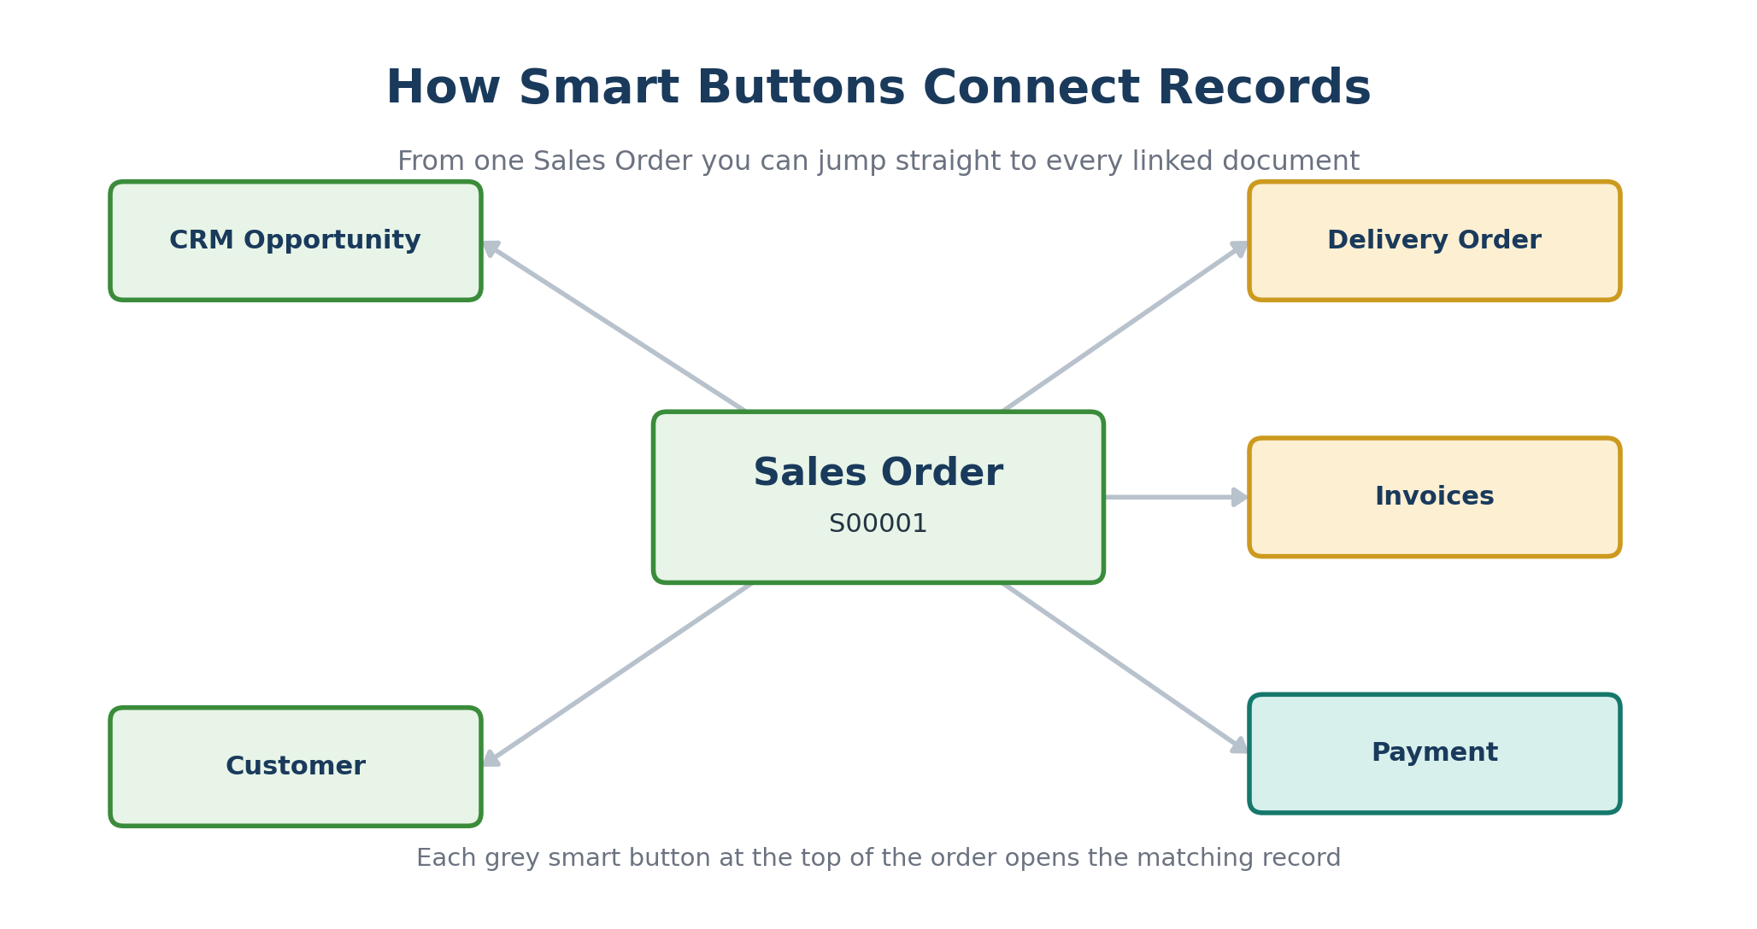
Figure 19. From one Sales Order, smart buttons reach the opportunity, customer, delivery, invoice, and payment.
The same idea repeats across the system: a Purchase Order has a Receipt button, a Manufacturing Order shows its components and finished product, and an Invoice links back to its Payment. Whenever you wonder “where did this come from?”, look for a smart button along the top of the record — it is the fastest way to trace the process backwards or forwards.
Tip During your demo, clicking smart buttons live is the clearest way to show that the departments are truly connected — one order, one click, and you are looking at the matching delivery or invoice.

